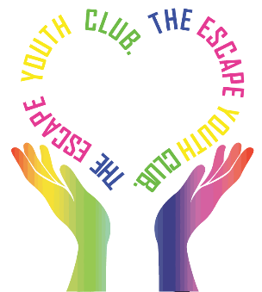
The Escape Youth Club are hosting a Dodgeball Championship at the St Johns Park tennis courts in Burgess Hill on Sunday 14th June.
With space for up to 12 adult teams (age 18+) competing from 11am - 1pm and 12 junior teams (age 11-17) from 1.30pm to 3.30pm its time to get your dodge on and register a team/teams to join in the fun and help support The Escape Youth Club!
Teams are a minimum of 6 and a maximum of 8 players with £5 entry per adult and £1.50 per junior - If you would like to sign up, please complete the form and return by the end of April (on a first come first served basis). Thank you.
Team Name:
Main Contact Name:
Contact Number:
Email Address:
Address:

Type of Team/s: |  | Adult (Aged 18+) |  | Junior (11 – 17)
No of Players in Team:
Players Names:
Paid Entrance Fee by: |  | BACS |  | Cheque
To confirm your teams place in the Dodgeball fun please make your payment to the following:
The Escape Youth Club Sort Code No: 09-01-29 Account No: 36321210
CLUB USE ONLY
Dodgeball Team Name: Contact Name:
Payment Paid By/Date: Contact Number:
Amount: Allocate Team Slot:

